**Estimation of R(Tj) from ASC test data**

Forster thermal model:

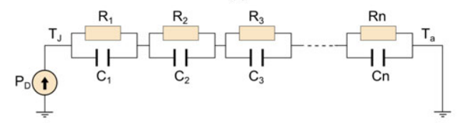

$$P_{C1}=C_{1}\frac{dT_{1}}{dt}$$

$$P_{R1}=\frac{T_{1}}{R_{1}}$$

$$P_{D}=P_{C1}+P_{R1}$$

$$T_{J}=T_{1}+T_{2}+…+T_{n}+T_{a}$$

$$P_{D}=C_{1}\frac{dT_{1}}{dt}+\frac{T_{1}}{R_{1}}$$

$$\frac{d}{dt}T_{1}=-\frac{1}{C_{1}R_{1}}T_{1}+\frac{1}{C_{1}}P_{D}$$

In the same way we can formulate the temperature drop across the other elements in the foster chain and write in the state space matrix form.

$$\frac{d}{dt}\left[\begin{matrix}T_{1} \\ T_{2} \\ ⋮ \\ T_{n}\end{matrix}\right]=\left[\begin{matrix}-\frac{1}{R_{1}C_{1}} & 0 & ⋯ & 0 \\ 0 & -\frac{1}{R_{2}C_{2}} & 0 & 0 \\ ⋮ & 0 & ⋱ & ⋮ \\ 0 & 0 & ⋯ & -\frac{1}{R_{n}C_{n}}\end{matrix}\right]\left[\begin{matrix}T_{1} \\ T_{2} \\ ⋮ \\ T_{n}\end{matrix}\right]+\left[\begin{matrix}\frac{1}{C_{1}} & 0 \\ \frac{1}{C_{2}} & 0 \\ ⋮ & 0 \\ \frac{1}{C_{n}} & 0\end{matrix}\right]\left[\begin{matrix}P_{D} \\ T_{a}\end{matrix}\right]$$

$$T_{J}=\left[\begin{matrix}1 & 1 & ⋯ & 1\end{matrix}\right]\left[\begin{matrix}T_{1} \\ T_{2} \\ ⋮ \\ T_{n}\end{matrix}\right]+[\begin{matrix}0 & 1\end{matrix}]\left[\begin{matrix}P_{D} \\ T_{a}\end{matrix}\right]$$

$$\dot{x}=Ax+Bu$$

$$y=Cx+Du$$

With

$x=\left[\begin{matrix}T_{1} \\ T_{2} \\ ⋮ \\ T_{n}\end{matrix}\right]$, $u=\left[\begin{matrix}P_{D} \\ T_{a}\end{matrix}\right],y=T_{j}$

$A=\left[\begin{matrix}-\frac{1}{R_{1}C_{1}} & 0 & ⋯ & 0 \\ 0 & -\frac{1}{R_{2}C_{2}} & 0 & 0 \\ ⋮ & 0 & ⋱ & ⋮ \\ 0 & 0 & ⋯ & -\frac{1}{R_{n}C_{n}}\end{matrix}\right]$, $B=\left[\begin{matrix}\frac{1}{C_{1}} & 0 \\ \frac{1}{C_{2}} & 0 \\ ⋮ & 0 \\ \frac{1}{C_{n}} & 0\end{matrix}\right]$, $C=\left[\begin{matrix}1 & 1 & ⋯ & 1\end{matrix}\right]$, $D=[\begin{matrix}0 & 1\end{matrix}]$

The discrete state space model can be written as

$$x_{k+1}=A_{d}x_{k}+B_{d}u_{k}$$

$$y_{k}=C_{d}x_{k}+D_{d}u_{k}$$

With

$$A_{d}=e^{AT_{d}}$$

$$B_{d}=\left(\int_{0}^{T_{d}}{e^{At}}dt\right)B=A^{-1}\left(e^{AT_{d}}-e^{A0}\right)B=A^{-1}\left(A_{d}-I\right)B$$

Since A is diagonal

$$A_{d}=e^{AT_{d}}=\left[\begin{matrix}e^{-\frac{T_{d}}{R_{1}C_{1}}} & 0 & ⋯ & 0 \\ 0 & e^{-\frac{T_{d}}{R_{2}C_{2}}} & 0 & 0 \\ ⋮ & 0 & ⋱ & ⋮ \\ 0 & 0 & ⋯ & e^{-\frac{T_{d}}{R_{n}C_{n}}}\end{matrix}\right]$$

And $B_{d}$

$$B_{d}=\left[\begin{matrix}R_{1}C_{1}(1-e^{-\frac{T_{d}}{R_{1}C_{1}}}) & 0 & ⋯ & 0 \\ 0 & R_{2}C_{2}(1-e^{-\frac{T_{d}}{R_{2}C_{2}}}) & 0 & 0 \\ ⋮ & 0 & ⋱ & ⋮ \\ 0 & 0 & ⋯ & R_{n}C_{n}(1-e^{-\frac{T_{d}}{R_{n}C_{n}}})\end{matrix}\right]\left[\begin{matrix}\frac{1}{C_{1}} & 0 \\ \frac{1}{C_{2}} & 0 \\ ⋮ & 0 \\ \frac{1}{C_{n}} & 0\end{matrix}\right]$$

$$B_{d}=\left[\begin{matrix}R_{1}\left(1-e^{-\frac{T_{d}}{R_{1}C_{1}}}\right) & 0 \\ R_{2}\left(1-e^{-\frac{T_{d}}{R_{2}C_{2}}}\right) & 0 \\ ⋮ & 0 \\ R_{n}\left(1-e^{-\frac{T_{d}}{R_{n}C_{n}}}\right) & 0\end{matrix}\right], C_{d}=C and D_{d}=D,$$

Where $T_{d}$ is the sampling time

**Modelling of Rds on as function of Tj and Id based on VI-Curve measurement and Thermal model.**

Given are the measurements vector $v_{ds}={\left[v_{1},v_{2},…,v_{n}\right]}^{T}$ the corresponding current vector $i_{d}={\left[i_{1},i_{2},…,i_{n}\right]}^{T}$ and the corresponding time vector $t={\left[t_{1},t_{2},…,t_{n}\right]}^{T}$

With the losses vector and thermal model the junction temperature can be calculated and the junction temperature can be given as $T_{j}={\left[T_{j1},T_{j2},…,T_{jn}\right]}^{T}$

$$Therefore the following can be assumed given:$$

$$t={\left[t_{1},t_{2},…,t_{n}\right]}^{T}$$

$$v_{ds}={\left[v_{1},v_{2},…,v_{n}\right]}^{T}$$

$$i_{d}={\left[i_{1},i_{2},…,i_{n}\right]}^{T}$$

$$T_{j}={\left[T_{j1},T_{j2},…,T_{jn}\right]}^{T}$$

|  |  |  |  |  |
| --- | --- | --- | --- | --- |
| n | $$t$$ | $$R_{ds}$$ | $$i_{d}$$ | $$T_{j}$$ |
|  |  |  |  |  |
|  |  |  |  |  |
|  |  |  |  |  |
|  |  |  |  |  |
|  |  |  |  |  |

The VI curve was measured at 3 temperatures $T_{C}=[T_{C1},T_{C2},T_{C3}]$

The general model is polynomial 3 order:

$$v_{ds}=v_{0}+R_{0}i_{d}+k_{0}i_{d}^{2}+k_{1}i_{d}^{3}$$

Where $v_{0},R_{0},k_{0},k_{1}$ are $f(T_{c})$

We also define that:

$$R_{ds}=\frac{dv_{ds}}{di_{d}}=R_{0}+2k_{0}i_{d}+3k_{1}i_{d}^{2}$$

$$R_{ds}(i_{d},T_{C})=R_{0}(T_{C},T_{j})+2k_{0}(T_{C},Tj)i_{d}+3k_{1}(T_{C},T_{j})i_{d}^{2}$$

Assuming that:

$$v_{0}=v_{00}+v_{01}T_{C}+v_{02}T_{C}^{2}$$

$$R_{0}=R_{00}+R_{01}T_{C}+R_{02}T_{C}^{2}$$

$$k_{1}=k_{10}+k_{11}T_{C}+k_{12}T_{C}^{2}$$

$$k_{2}=k_{20}+k_{21}T_{C}+k_{22}T_{C}^{2}$$

$$R_{ds}I^{2}=P_{v}=R_{0}+2k_{0}i_{d}+3k_{1}i_{d}^{2}$$

$$\frac{T_{j}-T_{c}}{Z_{th}i_{d}^{2}}=R_{ds}=R_{0}+2k_{0}i_{d}+3k_{1}i_{d}^{2}$$

What we have is:

$$t={\left[t_{1},t_{2},…,t_{n}\right]}^{T}$$

$$v_{ds}={\left[v_{1},v_{2},…,v_{n}\right]}^{T}$$

$$i_{d}={\left[i_{1},i_{2},…,i_{n}\right]}^{T}$$

$$R_{ds}={\left[R_{ds1},R_{ds2},…,R_{dsn}\right]}^{T}$$

$$T_{j}={\left[T_{j1},T_{j2},…,T_{jn}\right]}^{T}$$

We would like to have:

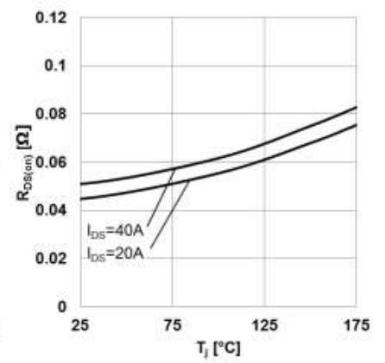

$$R_{ds}=\frac{v_{0}}{i_{0}}+2k_{0}i_{d}+3k_{1}i_{d}^{2}$$